Data Reporting
Data Cleaning and Code:
All coding parts are in this link. Please TuanTruongusfca/Econ692_Capstone
Data Description:
This research combines data from multiple sources to identify the causal effects of working from home on housing price in California from 2013 to 2023. Housing price datasets were obtained from Zillow’s County Home Value Index (ZHVI), measured annually at the zip-code level. The outcome variable is the logarithm of median home value. Working-from-home (WFH) data are collected from the American Community Survey (ACS), which reports the share of workers working from home by zip-code and year. The main treatment variable is the percentage of workers working from home. Control variables include median household income, population, and the federal funds rate (Federal Reserve). The datasets are merged using zip codes and year identifiers. Zip-Codes with missing key variables are excluded from the analysis.
Summary Statistics and Basic Data Checks:
Based on the below statistical table, the dataset contains 15,868 observations from 2013 to 2023. The average of log housing price is 13.08 with standard deviation of 0.68 indicating the fluctuation across zip-code in California. The average of working from home is 72 percent with 11.95% of standard deviation. The range from 0 to 100 shows that working from home shares vary across area. In addition, median household income have approximately 77,000 dollar with a standard deviation of nearly above 35,000 dollar. The median income, which is between 68,000 and 247,000, indicates a dispersion across California. Meanwhile, the population averages roughly 26,549 per zip-code.

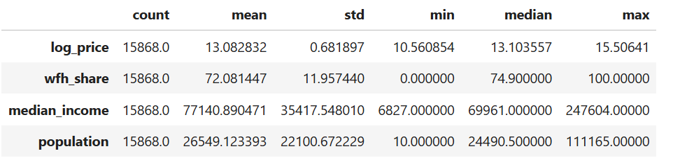
Table 1: Summary Statistic
Data Limitation
First, ZIP code levels are administrative postal boundaries. They may change over time. These adjustments can make the panel structure inconsistent and introduce measurement error. Second, the datasets still contain many missing values. Dropping these observations might lead to bias in the analysis and affect the estimation of the causal effect. Third, migration during the COVID-19 pandemic may confound the causal relationship between working from home and housing prices. Areas with higher population inflows may experience both higher working-from-home shares and rising housing prices. In this case, working from home may no longer directly affect housing prices, as the observed relationship could be driven by migration. Fourth, the datasets may not capture important local factors such as amenities, utilities, or school quality in each ZIP code. These factors clearly influence housing prices and should ideally be controlled for in the analysis.
Empirical Strategy:
The research model uses a fixed effect specification to estimate the causal effect of working from home on housing price as:
$$\log\left(price\right)=α+ β1×WFH+ β2×MedianIncome+ β3×population+FE\left(Zipcode\right)+FE\left(Year\right)+µ$$
Where FE(Zipcode) is added to control for time-invariant zip_code characteristics and FE(Year) is year fixed-effect that control for macro shocks like interest rate.
Remaining Gaps:
There are two major identification concerns. First, a potential backdoor path arises if rising housing prices attract higher-income remote workers, rather than WFH causing housing price increases. This introduces reverse causality. Second, unobserved ZIP code characteristics—such as amenities, crime rates, and school quality—may independently drive housing price growth. If these factors are correlated with WFH exposure, omitted variable bias may distort the estimated causal effect.

